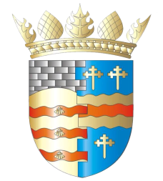
BLAIRGOWRIE AND RATTRAY COMMUNITY COUNCIL

Draft Agenda Ordinary Meeting
Thursday, 8th January 2026, at 7pm
in the BaRI Building, High Street, Blairgowrie
and online via Zoom

Ordinary Meeting

1. Welcome and Introductions
2. Apologies
3. Adoption of draft minutes of 9th November 2025 meeting
4. Police & Fire Reports
5. Matters raised by members of the public
a) LDP 3
b) McDonald’s Drive-Thru
6. Matters Arising/Reports Back
a) Gallowbank Footpath
b) Top up tap
c) Recreation centre (Pool) update
7. Regular reports
a) Report from our young representatives
b) Resilience/Flooding/First Responders PR/SM
c) Climate Action DC/GP/JM
d) Twinning GP/SM/DC/AS
e) Maintenance in Blairgowrie & Rattray
i. Built Environment
a) Electrical Connections at Wellmeadow
ii. Open Spaces
8. Traffic Matters
a) Speeding Meeting
9. Planning Matters
10. Chair’s Report
11. Treasurer’s Report
12. Councillors’ Reports
13. AOCB

Please note: With the permission of all attendees, the minute taker will record this meeting solely for the purpose of writing up the minutes, will not share the recording, and will delete the recording as soon as the minutes have been written. The Chair will ask for permission at the start of the meeting.

Awaiting info: CCTV, Community Action Plan, Local Place Plan, Football Pitch, CotY, Riverside safety, Emma Street laundry

Next meeting: Ordinary Meeting, Thursday, 12th February 2026, 7.00pm,
at the BaRI Building, Blairgowrie & online

