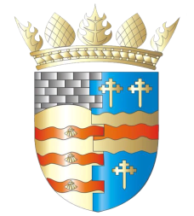
BLAIRGOWRIE AND RATTRAY COMMUNITY COUNCIL

Ordinary Meeting
Thursday, 12th May 2022, at 7pm
at the BaRI building, High Street, Blairgowrie, and online via Zoom

1. Welcome and Introductions
2. Apologies
3. Adoption of draft minutes of 14 April 2022 meeting
4. Matters raised by members of the public
a) UN World Environment Day
5. Matters arising/reports back
a) Resilience/Flooding PR/SM
b) Climate Action - Earth Day DC/GP
c) Twinning GP
d) Macpherson Memorial RD
e) Cottage Hospital CS
f) David Bailey bench RD
g) CCTV for the town PR
h) Community Action Plan RD/SS
i) Noticeboards CS/SS
j) Representation of Young People SM/SS
k) Citizen of the Year SM
l) Town Flag SM/SS
m) Jubilee Weekend
6. New Projects
7. Traffic Matters
8. Planning Matters
9. Police & Fire Reports
10. Chair’s Report
11. Treasurer’s Report
12. Secretary’s Correspondence
13. Councillors’ Reports
14. AOCB

Please note: With the permission of all attendees, the minute taker will record this meeting solely for the purpose of writing up the minutes, will not share the recording, and will delete the recording as soon as the minutes have been written. The Chair will ask for permission at the start of the meeting.

Next meeting: Ordinary Meeting, Thursday, 9th June 2022, 7.00pm

