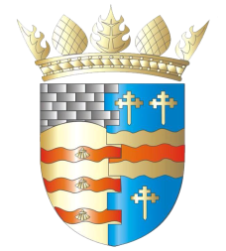

**BLAIRGOWRIE AND RATTRAY COMMUNITY COUNCIL**

**Ordinary Meeting – Draft Agenda**

**Thursday, 13th March 2025, at 7pm**

**at the BaRI Building, High Street, Blairgowrie,**

**and online via Zoom**

1. Welcome and Introductions

2. Apologies

3. Adoption of draft minutes of 13th February 2025 meeting  
 4. Police & Fire Reports

5. First Responders - Neil Hardy, NHS Community Resilience Facilitator

6. Matters raised by members of the public

7. Regular reports

a) Resilience/Flooding PR/SM

b) Climate Action DC/GP/JM

c) Twinning GP/SM/DC/AS

d) Maintenance in Blairgowrie & Rattray

i. Built Environment a) Electrical Connections at Wellmeadow

ii. Open Spaces

e) Local Place Plan

8. Matters Arising/Reports Back

a) B&R Common Good Fund

b) First Responders in B&R

c) Scalable Cities

d) Elm Drive Traffic/Speeding on Coupar Angus Road

e) Citizen/Young Person/Group of the Year

f) Strathmore Stronger Communities

g) Football Pitch

9. Traffic Matters

a) Closure of Blairgowrie to Alyth Road A926 re Gas Repairs

10. Planning Matters

11. Chair’s Report

12. Treasurer’s Report

13. Secretary’s Correspondence

14. Councillors’ Reports

15. AOCB

Please note: With the permission of all attendees, the minute taker will record this meeting solely for the purpose of writing up the minutes, will not share the recording, and will delete the recording as soon as the minutes have been written. The Chair will ask for permission at the start of the meeting.

Awaiting info: CCTV, Representation of Young People, Community Action Plan

**Next meeting: Ordinary Meeting, Thursday, 10th April 2025, 7.00pm**