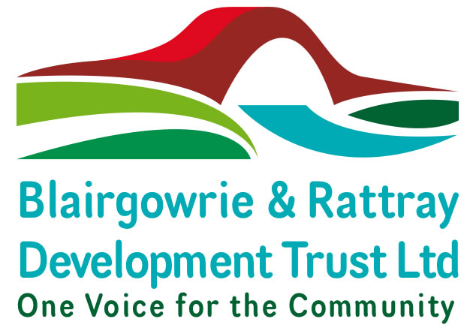

**Community Asset Purchase**

**Mount Ericht Walled Garden**

**Business Plan 2020 – 2025**

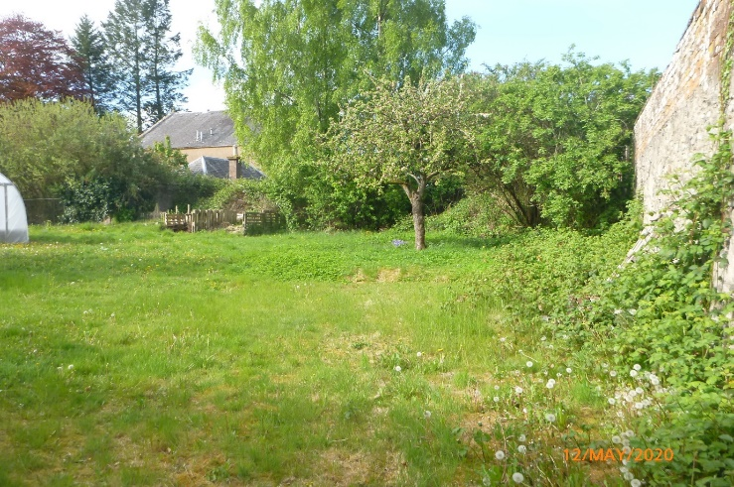

**Supporting Blair in Bloom & Partners**

**To Create a Community Garden for the Town**

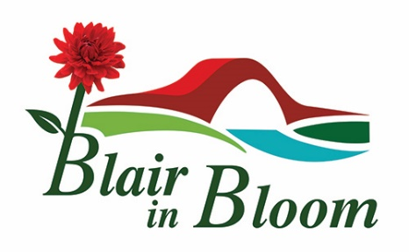

**CONTENTS**

|  |  |
| --- | --- |
| **Page No** | **Section** |
| 3 | Acknowledgements and List of Contributors |
| 4 | 1.0 Executive Summary |
| 5 | 2.0 Information about the Community of Blairgowrie & Rattray |
| 5 | 2.1 The Town and its Heritage |
| 6 | 2.2 Community Needs |
| 6 | 2.2.1 Children and Families Living in Poverty |
| 8 | 2.2.2 Community Gardens in areas of Deprivation |
| 8 | 2.2.3 [1]The Local Action Plan |
| 8 | 2.2.4 Local Outcomes Improvement Plan Perth & Kinross 2017-2027 |
| 9 | 2.3 Consulting the Community – Survey Monkey March 2020 |
| 10 | 3.0 About Blairgowrie & Rattray Development Trust Ltd |
| 13 | 3.1 About Blair in Bloom |
| 17 | 3.2 Joint Skills Analysis – The Trust and Blair in Bloom |
| 18 | 4.0 Project Background, |
| 19 | 4.1 Involving and Engaging the Wider Community |
| 19 | 4.2 Studies, Research and Consultation |
| 21 | 4.3 Key Findings and Learning Points |
| 23 | 5.0 The Project and Community Asset |
| 24 | 5.1 Site Option Comparison Schedule |
| 24 | 5.2 Site Photographs & Planning Map |
| 25 | 6.0 Project Aims and Objectives |
| 26 | 6.1 Community Garden Partners – Groups and schools ‘Signed Up’ |
| 27 | 6.2 High Level Implementation Plan with Measurable Outcomes |
| 30 | 6.3 Project Resources - Input from Partners and Stakeholders |
| 30 | 6.4 Recruitment and Training Plans |
| 30 | 6.5 Impact on Existing Blair in Bloom Work – Business Growth Plan |
| 31 | 6.6 Volunteer Resources |
| 32 | 6.7 Policy Audit |
| 32 | 7.0 Project Costs - Financial Analysis |
| 32 | 7.1 Expenditure Plan – 5 Years Running Costs |
| 33 | 7.2 Income Plan 5 Years Projection |
| 34 | 7.3 Total Capital Fund Requirement |
| 34 | 7.4 Prospective Staffing Costs |
| 34 | 7.5 Costs to The Trust |
| 35 | 8.0 Community Garden Funding Plan 2020-2025  9.0 Financial Analysis |
| 37 |
| 39 | 10.0 Marketing & Communication Plan |
| 44 | 1. Risk Analysis |
| 46 | 1. Monitoring & Evaluation |

**Appendices** are contained in the separate accompanying ‘**Supporting Documents’**

**The Business Plan was Prepared By:**

Lorna McCurrach Development Officer Blairgowrie & Rattray Development Trust

Mary Birch Chair, Blair in Bloom

William Wilson Committee Member, Blair in Bloom

Janine Seymour Vice Chair, Blair in Bloom

Alison Powrie, Marketing Blairgowrie & Rattray Development Trust

Gail Morrison, Finance Manager Blairgowrie & Rattray Development Trust

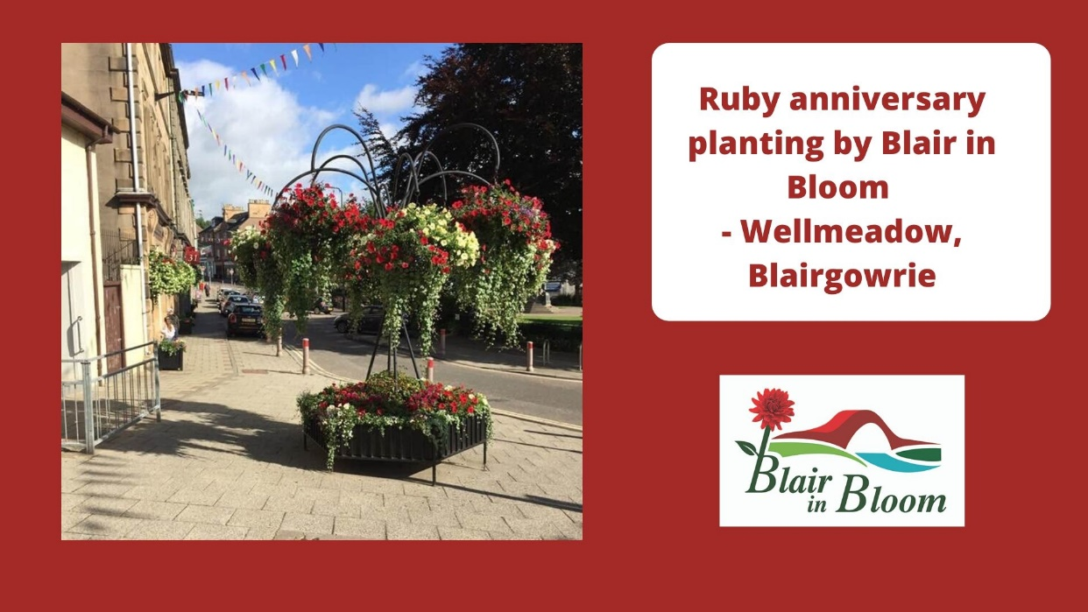

**Celebrating Forty Years of Blair in Bloom**

**Contributors and Advisors**

Calum Couston, Scottish Land Fund Advisor – Community Assets Team

Melissa Reilly Lanarkshire Development Trust – Castlepark Horticultural Centre

Brighter Bothwell Environment Group

PLUS, Perth & Kinross – Horner’s Plot and Loon Braes Community Gardens

**Enquiries:** Lorna McCurrach Development Officer [lorna.mccurrach@brdt.org.uk](mailto:lorna.mccurrach@brdt.org.uk)

1. **Executive Summary**

Blairgowrie and Rattray Development Trust is delighted to be working with partner Blair in Bloom to secure the land at Mount Ericht for a Community Garden. This project will undoubtedly bring considerable benefits to the town for many years to come. Pursuing ownership of this Community Asset is both a key role of the Trust as a Community Anchor Organisation, but also a hugely exciting project that will boost the morale of the town as it comes through exceedingly difficult times due to the Coronavirus pandemic.

Blair in Bloom approached The Trust in February 2020 to request assistance to acquire this Community Asset by means of a funding application to the Scottish Land Fund. As a long term leaseholder of the site, they recognised the untapped potential of the former walled garden, both for the wider benefits it could bring to the community as well as securing it for their continuing use. The Trust immediately agreed to take this forward having worked successfully alongside Blair in Bloom and also knowing their excellent reputation and valuable role in the town.

A winner of many awards, Blair in Bloom has been in operation for forty two years. It has held the lease for the walled garden at Mount Ericht for ten years. The site currently houses two polytunnels used to supply the planters and hanging baskets for the town. The remaining land is underused and has great untapped potential as a Community Garden.

The owner of the site is Caledonia Housing Association. The Trust and Blair in Bloom approached the Director of Assets Andrew Kilpatrick to guage their interest in selling and this was duly confirmed. Communication has been ongoing through the process of this application from the successful completion of Stage One through to this point at Stage Two.

Working alongside Calum Couston, Scottish Land Fund Advisor, the Trust and Blair in Bloom prepared this Business Plan to support the funding application. Having undertaken an assessment of community needs as well as consulting as widely as Coronavirus restrictions would allow, it is clear that a Community Garden at Mount Ericht would be very well placed to address a range of social, environmental, and economic needs within the community. Particular services and sectors such as tourism, education and children’s services, health and social care for older people and youth services are just some of the areas where the garden could make a positive impact.

Community support for this project is evident through the Survey Monkey survey undertaken in March 2020 for Stage One of the application. This study has been followed by a more targeted survey of groups and schools in the town to determine whether a community garden would meet the needs of their pupils or clients and also if they were interested in signing up to be involved. Eight groups and three primary schools have pledged their support and keen interest in participating.

Securing the Asset for the Community with the continuing support of The Trust will ensure the continuation of the valuable work carried out by the Blair in Bloom volunteers in improving and enhancing the environment for residents and visitors to the town. It will enable the development of a community garden for education, health, and well-being as well as growing fruit, vegetables, and flowers. Before it is even off the ground, this project has inspired and engaged a number of schools, groups, and individuals who intend/wish to participate and help with the Community Garden, ensuring its long term sustainability

The Business Plan clearly demonstrates that both The Trust and Blair in Bloom have effective governance, excellent volunteer teams and partner groups, supporters, resources, skills, and financial expertise to undertake Community Ownership and develop this exciting project to a successful conclusion.

**2.0 Information about the Community of Blairgowrie & Rattray**

This section includes a general description of the local community, geography, heritage, and demographics. The needs of the community have been identified through national data sources and local community planning partnership plans. Many of the key challenges and priorities for the area are set out in the town’s own Community Action Plan, the Local Outcome Improvement Plan for Perth and Kinross and the Local Action Plan for Eastern Perthshire.

**2.1 The Town and its Heritage**

Blairgowrie & Rattray is the largest town in Perth & Kinross with an estimated population of 9,060 (mid 2015). The population is growing at three times the rate of any other town in Scotland (National records for Scotland). A socio-economic study carried out as part of a Charrette to inform the current Community Action Plan identified that population growth and housing supply has grown much faster than economic activity. The attractiveness of public spaces, particularly in the heart of the town and the high street is a key element of sustaining community identity as more people seek work further afield.

The town lies north of Perth city with Blairgowrie as the larger settlement, southwest of the River Ericht and Rattray in the northeast. They were combined in 1928 by an Act of Parliament and are now locally referred to as “Blair” – the Scottish Gaelic word for a plain or open meadow.

Blairgowrie & Rattray has an industrial heritage situated along the banks of the River Ericht and was a significant contributor to the growth of the flax and later jute mills. As these industries harnessed the power of the river to drive the water wheels, the population grew with a workforce of over 3000 people. The decline of this industry in the early 20th century saw economic activity switch to soft fruit farming. Thereafter, the town was known worldwide as “the Berry Toon”. In its heyday, Smedley’s outputs were dispatched through distribution networks as far afield as Covent Garden.

While soft fruit production remains a key economic activity, the town is now significantly dependent on tourism for much of its viability. Together with a small number of diverse employers including large companies including Castle Water, this mix forms the current profile of local employment opportunities.

The asset at Mt Ericht is situated in Rattray which claims to be the older settlement. The area around Rattray Kirk dates back to the 12th century, while ‘New Rattray’ – the area along the Boat Brae and Balmoral Road dates from 1777 when the River was spanned by the Brig o’ Blair. Rattray is the location of the site at Mount Ericht.

**2.2 Community Needs**

A community garden at Mount Ericht would be well placed to address a range of social, environmental, and economic needs within the community. Particular services and sectors such as tourism, education and children’s services, health and social care for older people and youth services are just some of the areas where the garden could make a positive impact.

The site is located close to a neighbourhood of significant deprivation as evidenced by Public Health Scotland Observatory data and the demographic profiling undertaken for the Eastern Perthshire Locality Action Plan.

Blair in Bloom displays across the town have a significant impact on the attractiveness of the public spaces which is vitally important as the area relies heavily on tourism and day visitors.

**Community Online Survey March 2020**

In 2017 Perth & Kinross Council commissioned a Charette to inform the [2]Blairgowrie & Rattray Community Action Plan. The Blair in Bloom contribution is significant in three of the seven key areas prioritised for improvement:

* *More people live, work, and spend in the town*
* *More people chose to visit the town year round*
* *Blairgowrie & Rattray is recognised and renowned for its attractive public spaces, accessibility, and conscientious environmental approach*

**2.2.1 Children and Families Living in Poverty**

Low income households with children living in poverty is a significant feature of close neighbourhoods - [3]the average household income in adjacent settlements is £894 a week compared to £536 in parts of Rattray. At least 1 in 10 households in Eastern Perthshire are earning below the average household income for Scotland, meaning they are likely to be at risk of being in poverty. In Rattray, the figure is 1 in 5 households. Rattray has a higher rate of adults claiming incapacity benefits/ severe disability allowance than other rural localities in Perth and Kinross.

Scottish Public Health Observatory Data (2018) in these tables shows income disparity between Blairgowrie West.

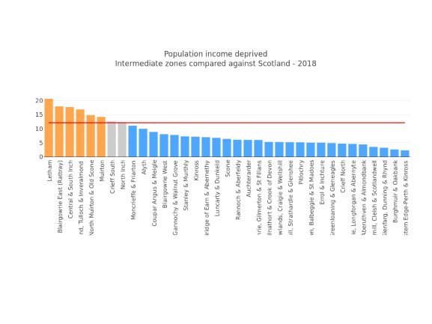

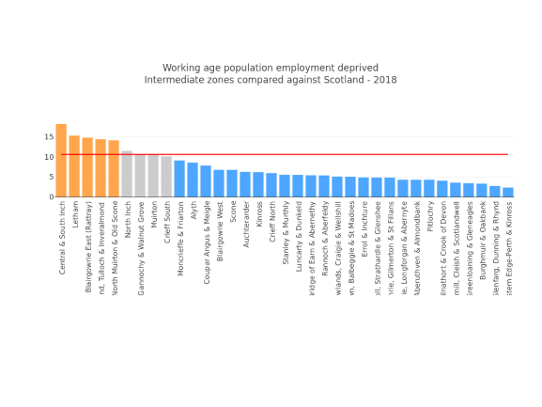

**2.2.2 Community Gardens in areas of Deprivation**

Whilst the relationship between growing up in poverty and outcomes in adulthood is complex, the experience can and does have long-lasting effects on a child’s health, development, education, and lifetime opportunities. Families living in poverty are at increased risk of adversity as well as having reduced access to resources to counteract the effects.

A [4]Case Study carried out by the Federation of City Farms and Community Gardens

demonstrates how projects such as these enable schools (particularly in areas of deprivation) to fulfil their responsibilities with respect to the [5]Outdoor Learning Strategy as well as offering varied and engaging topics that coincide with the Curriculum for Excellence.

[Every1’s Garden](https://www.facebook.com/watch/?v=2563652570319116) is an award winning project located in the Maxwelltown Information Centre at the heart of one of the most deprived areas in Dundee with similar challenges to areas of Rattray. The four local primary schools each have an allocated area in the garden for growing fruit and vegetables, which they maintain by bringing small groups and sometimes full classes to the centre to cultivate their plots. The project provides school activity sessions within the garden and outdoor classroom, as well as outreach sessions aimed at Eco groups from the schools.

*The opportunity to do outdoor learning is invaluable and many of the children who do not engage in school are thriving within the garden. Many teachers have noted the change in behaviour of some of the more challenging pupils, saying they are more “relaxed” and “willing to learn” in the garden environment. Pupils also feel the impact, with one saying the project was important as they were “being trusted to do the good jobs” giving them a sense of responsibility and increased confidence*

***Every1’s Garden Dundee - Case Study***

**2.2.3 [6]****The Local Action Plan** – Eastern Perthshire cites data from the Scottish Index of Multiple Deprivation (SIMD) This area contains some of the most deprived communities in Scotland, with Rattray being in the bottom 10% in Scotland. Child Poverty affects 1 in 5 children living in the locality after housing costs, such as rent, mortgage, council tax, heating etc have been considered. Eastern Perthshire has a higher rate of adults claiming incapacity benefits/ severe disability allowance than other rural localities in Perth and Kinross.

**2.2.4 Community Plan/Local Outcomes Improvement Plan (LOIP) Perth and Kinross (2017-2027)**

Local Community Planning partners published the plan in 2017 to bring about positive outcomes for everyone in the area; in particular to tackle stubborn, disadvantageous, and persistent inequalities which reduce life chances and opportunities for people. Developed in dialogue with residents of Perth and Kinross, achieving its shared vision will only be made possible by statutory agencies working alongside local people and communities.

A Community Garden at Mount Ericht would be well placed to contribute to four of the five LOIP strategic objectives:

* **Giving every child the best start in life** – outdoor classrooms, learning how to grow produce, creating habitats for wildlife
* **Promoting a prosperous, inclusive, and sustainable economy** – deploying a sizeable volunteer workforce in creating beautiful public spaces with floral displays
* **Supporting people to lead independent, healthy, and active lives** – enabling local people of all ages to enjoy the health benefits of gardening… and just being in a garden
* **Creating a safe and sustainable place for future generations -** maintaining the outstanding beauty of our urban and rural environments.

Blairgowrie and Rattray Development Trust acting as the local [7]‘*community anchor organisation’,* working alongside Blair in Bloom is in a strong position as custodian of the local Community Action plan to coordinate joint working between different supports and services, whose collaborative efforts can create a vibrant and inclusive community garden.

**2.3 Consulting the Community – The Trust Survey Monkey March 2020**

The Trust carried out this survey to present with the Stage One Application. Community support and approval was strongly evident in the responses. (Results are set out in **Supporting Documents Appendix A.**

This study has since been followed by a more targeted survey of groups and school in the town to determine what their clients and pupils need and their capacity and resources to contribute to a community garden. A number of those have signed up to participate in the community garden. Information about who these groups and organisations are and how they want to contribute is detailed in Section 6.1.

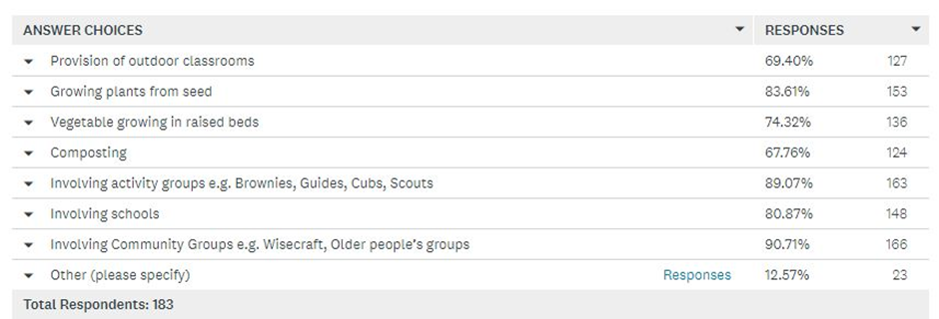

**3.0 About Blairgowrie & Rattray Development Trust Ltd**

**A Community-Led Anchor Organisation**

The community sector in Blairgowrie comprises informal, unconstituted and unfunded activities. Much of this activity remains ‘below the radar’ of the local authority and other public bodies. This local activity makes a significant contribution to the improvement agenda as well as generating the ‘social glue’ of cooperation. Alongside informal community life, there are a number of more formal and constituted voluntary organisations such as the Trust.

There is a substantial body of evidence to support the view that the most effective communities are those that are able to self-organise and respond effectively to challenges and opportunities. What these communities have in common is a particular type of [8]‘Community Anchor Organisation’ (CAO) which sits under the control and ownership of local people.

**Securing the Community Asset** for Blairgowrie and Rattray can be undertaken by The Trust in its role as a CAO. As in the case of the land at Mount Ericht, The Trust is working to secure this potential community asset and will also continue to provide a supportive role in taking the project forward to its conclusion.

**The Trust History & Background**

The Trust was established in May 2018 through a merger of the Ericht Trust and One Voice Volunteer Association. This coming together was recommended by Perth & Kinross Council in 2016 during the process of establishing the Community Action Plan. The aim was to create a central anchor organisation to simplify and improve coordination of regeneration and development activities across the town.

The Trust is a member of Development Trusts Association Scotland and a community-led group working alongside local people, other community groups, businesses, and Perth & Kinross Council towards the achievement of a number of shared regeneration outcomes. These are set out in the Blairgowrie & Rattray Community Action Plan, of which the Trust is the ‘custodian’ with responsibility for implementation, evaluation of outcomes and reporting of progress to the community and other stakeholders. As a Community Anchor Organisation, The Trust works to increase community involvement, build networks of mutual support; acting as one towards common purposes to build a stronger sense of community wellbeing and resilience.

The current Trust Development Plan (2020 – 2023) includes a range of outputs to address local regeneration priorities identified through wide community consultation. A Charette funded by the Council in 2016 shaped this Community Action Plan, which in turn informed the Trust Development Plan.

**Aims and Objectives**

The Trust Articles of Association (revised 5th June 2020) supports the purchase of the land at Mount Ericht as a Community Asset as evidenced by the extract below.

Full Trust Articles can be found in **Supporting Documents Appendix B**

**‘Objects’ relevant to this Business Plan are:**

*“The company has been formed to benefit the community of Blairgowrie and Rattray (defined as the towns of Blairgowrie and Rattray and the area within a six mile radius of the bridge over the river Ericht between Blairgowrie and Rattray) (“the Community”) with the following objects to be exercised following the principles of sustainable development (where sustainable development means development which meets the needs of the present without compromising the ability of future generations to meet their own needs) namely:*

* 1. *to manage community land and associated assets for the benefit of the community and the public in general*
  2. *to provide recreational facilities, or organise recreational activities which will be available to members of the community and public at large with the object of improving the conditions of life of the community*
  3. *to advance environmental protection or improvement including preservation, sustainable development and conservation of the natural environment, the maintenance, improvement or provision of environmental amenities for the community and/or the preservation of buildings or sites of architectural, historic or other importance to the community.”*

**The Trust Aims**

Much of the Trust’s work is focused on the Scottish Government Regeneration Outcomes Framework. With regard to *Physically Sustainable Communities* the Trust works alongside the Community Council to ensure people have access to quality public space and greenspace. Along with the Council, The Trust plans to map vacant and derelict land and property for potential use by community groups and others. Another aspect of this work is to support groups to use resources efficiently and respect the natural environment.

In aiming for *Socially Sustainable Communities,*  the Trust works in inclusive ways to ensure people and communities are involved in designing and delivering the services that matter to them. Much of the work is enabling the development of strong and effective community networks, ensuring people have access to decent and welcoming community facilities and places to meet. Through the Trust Community Support Programme, the Development Team works to empower individuals and groups to improve their area and maximise local assets.

In terms of *Economically Sustainable Communities* – the Trust works alongside Perth & Kinross Council, the Community Council and the local Business Association to strengthen the local economies, and to encourage a thriving high street and the development of both social and private enterprise.

**Legal Status**

* The Trust is a Company Limited by Guarantee and not having a share capital (The Companies Act 2006) No SC341257…
* It is also a registered Scottish charity No SC039702

**Structure and Governance**

The Trust has robust governance arrangements in place with a clear strategic lead by its Board of Trustees, a skilled Development Team and a cohort of twenty five regular volunteers and forty ‘occasional volunteers’.

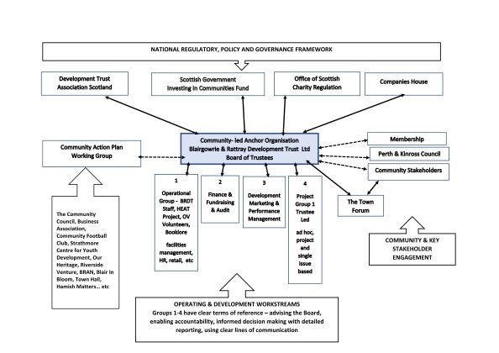

**The Trust Membership**

On 1st June 2020 there are 91 ordinary members. The Trust Development Plan seeks to significantly increase this membership as well as recruiting corporate members.

**3.2 About Blair in Bloom**

Blair in Bloom work alongside The Trust as a member of the Working Group for the [Blairgowrie & Rattray Community Action Plan](https://www.brdt.org.uk/blairgowrie--rattray-community-action-plan.html). Membership includes a number of key groups in the town who are also linked with Blair in Boom through shared projects such as riverside and pathway improvements.

Blair in Bloom is a member of the [9]Trust Community Support Programme – a service offering business and advice services for local community groups who through their activities and projects are making improvements to the town and for the people who live there. It is by means of this membership that the Trust has agreed to and is very keen to pursue the purchase of a community asset at Mount Ericht.

**History and Position** – the group was first formed in 1978 although not constituted until 1981, (the original Minute book is preserved), Their aim then was to *engage in activity towards improving the amenities of the town.*

*“Blair in Bloom make the town a pleasure to walk through and sit at various planted areas to enjoy the environment…with the added benefit of attracting wildlife such as butterflies, bees, birds…”*

*“Blair in Bloom do invaluable work which improves life for our community….”*

*“Blair in Bloom makes a big difference to how I feel about living in this town! “*

*“Blair in Bloom make a significant difference…it vastly improves the appearance of the town and gives everyone a huge sense of community”*

**Survey Monkey Responses – Community Views about Blair in Bloom March 2020**

With a 42 year history, Blair in Bloom is well established, highly respected with links to all parts of the local community and is very much at the heart of the town. It enjoys great support from both the local community and other groups.

**Aims** from the current **Blair in Bloom Constitution** states:

*“Improve the quality of the environment and appearance of the town for residents and visitors to Blairgowrie & Rattray through horticultural activity, encouraging environmental responsibility and community engagement”*

A copy of the Constitution is set out in **Supporting Documents Appendix C**

**Legal Status** – Blair In Bloom is a constituted group and a member of the [Take A Pride in Perthshire Association](https://www.prideinperthshire.co.uk/) which is a registered Charity (OSCR SC027774)

**Structure & Governance** – Chair, Vice Chair, Secretary, Treasurer and four committee members. Office bearers serve a minimum of 3 and maximum of 5 years

**Membership** –Take a Pride in Perthshire, the umbrella organisation for all Bloom groups in Perth & Kinross.

**Affiliations** – Blairgowrie & Rattray Development Trust, Keep Scotland Beautiful, Royal Horticultural Society and Social Farms & Gardens

**Awards and Commendations -** the group first entered Britain in Bloom in 1978 and received Highly Commended awards for a number of years through the1980s. In 1991, the group was awarded a Blue Ribbon by Beautiful Scotland – a rare award at that time and the only one that year. They went on to regularly win awards throughout the 1990s. With a new Committee in place in 2000, awards kept coming, regularly winning Gold Medals with Beautiful Scotland and Take a Pride in Perthshire. In 2013 Blair in Bloom was awarded a Silver Gilt medal by the Royal Horticultural Society - Britain in Bloom. 2019 saw the group win Gold with both Beautiful Scotland and Take a Pride in Perthshire, plus the award for Community Involvement and Best Small Town from Take a Pride in Perthshire.

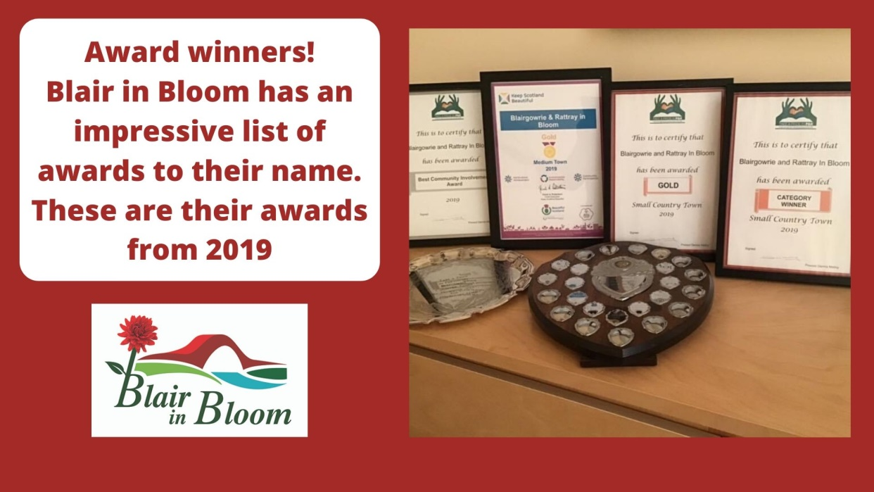

**Citizen of the Year** - Mary Birch, the current Chair was recently announced as joint winner of Citizen of the Year in recognition of the great work carried out by Blair in Bloom. The other winner Kay Seal runs the Climate Café – an important partner and supporter of the planned Community Garden.

**Volunteer Workforce** Blair in Bloom has twenty three long serving active volunteers, seven of whom are committee members. The skills mix, age and gender is diverse and fit for the purposes of the group. A volunteering policy is in place.

**Supporters of Blair in Bloom -** Blair in Bloom Honorary President is Sir William MacPherson of Cluny, who provides endless support and encouragement despite being 90+.

**Letters and Notes of Support** from the following organisations are in **Supporting Documents Appendix D**

* Our Heritage Group
* Blairgowrie & Rattray Access Network
* Blairgowrie & Rattray Community Council
* Pop Up Art Room Blairgowrie
* Blairgowrie Rotary Club
* Community Education – Perth & Kinross Council
* Climate Café
* Hamish Matters
* Local Councillors Bob Brawn and Caroline Shiers

**Key Partners and Stakeholders** In addition to the partnership with the Trust, Blair in Bloom has active and ongoing working relationships with at least thirteen key groups in the area. Their work is integral and woven through the very fabric of the town. Without exception all these groups value, respect and are keen to continue their collaboration.

[Blairgowrie & Rattray Access Network](https://www.facebook.com/pg/braccessnetwork/about/?ref=page_internal) – a volunteer group facilitating greater community and visitor participation, co-operation, and enjoyment in the activities of non-motorised recreational activities. Keeping the local network of paths clear and usable by everyone.

[Our Heritage](https://www.facebook.com/pg/Our-Heritage-Blairgowrie-Rattray-269616800358074/about/?ref=page_internal) – a volunteer group which promotes, preserves, and celebrates the cultural, economic, and social heritage of the town. It was also formed to establish a long-term solution to display and promote this heritage within a suitable venue

[Blairgowrie & Rattray Business Association](https://www.barba.org.uk/) – a member organisation supporting the prosperity of local businesses, the town and community.

[Proactive Communities](https://www.facebook.com/discoverblairgowrie/posts/the-business-associations-proactive-communities-project-aims-are-to-develop-a-su/2747938215285220/) – the Business Association's Proactive Communities project aims to develop a sustainable ecosystem of activities to promote the town.

[Climate Café -](https://www.facebook.com/groups/681698931994975/about/) bringing people together each month to work out what be done locally to reduce the impact of climate change - developing on-going and new local initiatives - local food, local transport etc

[Strathmore Centre for Youth Development](https://scyd.org.uk/about-us/) - provides a safe and supportive community where young people are valued and develop skills for life. Blair in Bloom’s association with SCYD originated with the development of The Meeting Place in Croft Lane - opened in 2011 as an outdoor social space for youngsters to use. Blair in Bloom revamped it all in 2019.

Riverside Venture Group – working on a number of initiatives to enhance areas along the river Ericht, one of the town’s greatest assets and visitor attractions.This group share three Blair in Bloom and one Trust Committee Member.

[Newly formed Riverside Project Group](https://www.discoverblairgowrie.co.uk/)set up by [Discover Blairgowrie](https://www.discoverblairgowrie.co.uk/) Blair in Bloom is part of this group - still in the initial development stages. [David F Wilson Sculptor](https://dfwilson.co.uk/) is involved. Adding new visitor attractions - a series of artworks and environmental improvements along the Riverside.

[Blairgowrie & Rattray Community Council](https://www.google.com/search?q=Blairgowrie+%26+Rattray+Community+Council&rlz=1C1ZKTG_enGB847GB847&oq=Blairgowrie+%26+Rattray+Community+Council&aqs=chrome..69i57j69i60.2167j0j8&sourceid=chrome&ie=UTF-8) a local voluntary organisation set up by statute through the Local Authority and run by local residents to act on behalf of this area. The Chair is also an enthusiastic and active Blair in Bloom volunteer.

[Community Greenspace Team – Perth & Kinross Council](https://www.pkc.gov.uk/article/15237/Community-Greenspace-) work in partnership on all the main 'green' areas of the town.  Prior to lockdown we were discussing further improvements to The Wellmeadow, following the 2018 revamp of one area.  The Terrace Garden of the Riverside is mainly looked after by Blair in Bloom. Subject to agreement with the Greenspace Officers it is planned to replant some areas, remove the raised beds (which will go to Mount Ericht), repair the retaining wall and lay a new surface. Other joint work has included Loon Braes and developing its pond as a nature park

[Wisecraft](https://www.pkavs.org.uk/Wisecraft) recently members of this mental wellbeing group helped to tidy the riverside borders and are keen to stay involved.

Community Payback clients have assisted on a number of occasions

[PKC Countryside Trust](https://www.pkct.org/) and artist [Martin McGuiness](https://martinmcguinness.co.uk/about/) artist who designed

the [Hamish Henderson portrait](https://www.thecourier.co.uk/fp/news/local/perth-kinross/1006184/video-giant-portrait-of-blairgowrie-poet-takes-shape-on-perthshire-hillside/) at Glenshee are collaborating on the Coronation Corner project.  The Countryside Trust is keen to have the site marked as the 'official' start of The Cateran Trail, and Martin is looking at murals illustrating the history of the town - drovers road, mills, river, etc.

**3.2 Joint Skills Analysis – The Trust and Blair in Bloom**

The Trust will continue to help and support this project to its completion. On acquiring the asset, the development of the Community Garden will be taken forward by a Steering Group with the required mix of skills to progress this project towards completion.

Specialist skills and knowledge will be available to this group from current membership and affiliation with the following organisations:

* Take a Pride in Perthshire - the umbrella organisation for all Bloom groups in Perth & Kinross
* Blairgowrie & Rattray Development Trust Ltd
* Keep Scotland Beautiful
* Royal Horticultural Society
* Social Farms & Gardens UK (Scotland)

**General & Specific Skills Analysis**

**Basic Skills Audit**

|  |  |
| --- | --- |
| **Development Trust (Trustees)** | |
| Stuart Nichol (Chair) | Architect & Local Authority Director |
| Brian Smith (Vice Chair | Engineer & Health & Safety Consultant |
| Eileen Ferguson | Chartered Accountant |
| Bill Taylor | Conservation/recreation management & heritage-based tourism |
| Len Seal | Social Work, Service Management, Climate Change |
| Tracie Dick | Banking, Web Development & Social Enterprise |
| **Development Trust (Staff)** | |
| Lorna McCurrach | Planning Development, Programme & Project Management |
| Gail Morrison | Chartered Accountant & Business Owner |
| Alison Powrie | Marketing and Communications |
| **Blair in Bloom Committee** | **Professional Experience/Skills** |
| Mary Birch (Chair) | Administration & Business Support |
| Janine Seymour (Vice Chair) | Education -Teacher |
| Avril Wilson | Administration & Business Support |
| William Wilson | Project Manager & Engineering |
| Pat Lumsden | Financial Admin. |
| Phil Seymour | Personnel Management |
| Ian Cruickshank | Ex-Military & Garden Centre Owner |
| Morag Reid | Education -Teacher |

**Skills Analysis [ No skill x ] [Competent ✓ ] [Skilled ✓✓ ]**

|  |  |  |  |
| --- | --- | --- | --- |
| **General Skills** | **Blair in Bloom** | **The Trust** | **Notes** |
| Chairing & Facilitation of Meetings | **✓✓** | **✓✓** | Blair in Bloom is a regular contributor to local press and community magazine, highly active on Twitter and Facebook. Website currently under construction.  They are also working closely with P&K Countryside Trust to develop a sizeable site in the town as the start of the Cateran Trail |
| Managing Meetings/Steering Groups | **✓✓** | **✓✓** |
| Communications – Written, Verbal & Digital | **✓✓** | **✓✓** |
| Community Engagement | **✓✓** | **✓✓** |
| Problem Solving | **✓✓** | **✓✓** |
| Business & Project Management | **✓✓** | **✓✓** |
| Risk Analysis & Management | **✓✓** | **✓✓** |
| Working with Volunteers | **✓✓** | **✓✓** |
| Financial Management | **✓✓** | **✓✓** |
| Funding & Fund Raising | **✓✓** | **✓✓** |
| **Specific Skills for an**  **Asset Ownership Project** | | | |
| **\*Legal** | **X** | **X** | *The Trust has access to legal services through DTAS & Insurance Policy  Trustee (BT) managed country parks and nature reserves for 16 years. Included overseeing an historic listed garden. Managed a tree nursery that grew 50,000 native trees from seed every year |
| Architecture/Planning | **x** | **✓✓** |
| Land Management | **x** | **✓✓** |
| Horticulture & Garden Design | **✓✓** |  |
| Social Care/Opportunities for Vulnerable Groups | **✓** | **✓✓** |
| Creating Educational Programmes (All Ages) | **✓✓** | **x** |
| Developing a Social Enterprise | **✓** | **✓✓** |
| Recruitment of Employees & Personnel | **✓✓** | **✓✓** |
| Business and Retail | **✓✓** | **✓✓** |

**4.0 Project Background**

In recognising the full potential of this site and the need to secure space for their polytunnels, Blair in Bloom approached The Trust in February 2020 requesting assistance to acquire this community asset; both for the wider benefits it could bring to the town and for their continuing use. The Trust were delighted to take this forward through their Community Support Programme.

Blair in Bloom has held a lease for this walled garden at Mount Ericht for ten years. The site currently houses two polytunnels used to supply the planters and hanging baskets for the town. The remaining land is underused and has great potential as a community garden.

The owner is [Caledonia Housing Association](https://www.caledoniaha.co.uk/) who are willing to sell as the site is not suitable for their development plans. Blair in Bloom commissioned a valuation in May 2020 which priced the land at £30,000. The valuation commissioned by Caledonia is £35,000. The Trust will attempt to negotiate a purchase price of £30,000 upon securing funds.

The project is entirely in keeping with the aims of The Trust, particularly in respect of the consultation undertaken by the Charrette in 2016 for the Community Action Plan which identified a number of priorities for the town that a community garden would contribute towards:

* *More people live, work, and spend in the town*
* *More people chose to visit the town year round*
* *Blairgowrie & Rattray is recognised and renowned for its attractive public spaces, accessibility, and conscientious environmental approach*

**4.1 Involving and Engaging the Wider Community**

Coronavirus restrictions curtailed plans to hold an event on site for the wider community. Blair in Bloom and The Trust had planned to issue an open invitation to anyone interested in seeing the garden, meeting the volunteers and Trust staff, finding out about plans, offering suggestions and joining a mailing list for updates about progress. An event such as this would also have gone some way to establish friendly relationships with neighbours and potential contributors to the project.

Alternative engagement has included the following:

* Published articles in the local press – See **Supporting Documents Appendix E**
* Newsletter and Poll of Trust Membership **Appendix E**
* Summer edition (page 7) [Trust Hub Magazine](https://www.yumpu.com/en/document/read/63427748/blairgowrie-rattray-hub-magazine-summer-2020)

**4.2 Studies, Research and Consultation**

Due to Covid-19 restrictions, this has largely been undertaken by ‘desk-top’ exercise and telephone interview. In ordinary times visits to other established community gardens would have been undertaken.

**A Survey Monkey exercise for Stage One Application** – See **Appendix A** for the full Report of Findings

**Engagement and Consultation with The Trust Membership**

On June 5th, by Mailchimp Newsletter and letters to those not online, Trust members were consulted and asked to vote on whether they supported or did not support the project and offered the opportunity to ask questions or offer comments. A reminder was issued on 9th June. The results are as follows:

91 Members Polled 57% return rate

* Postal Votes Received Yes - 4
* Online Results Received Yes – 52

Total Yes Votes 56

Total No Votes 0

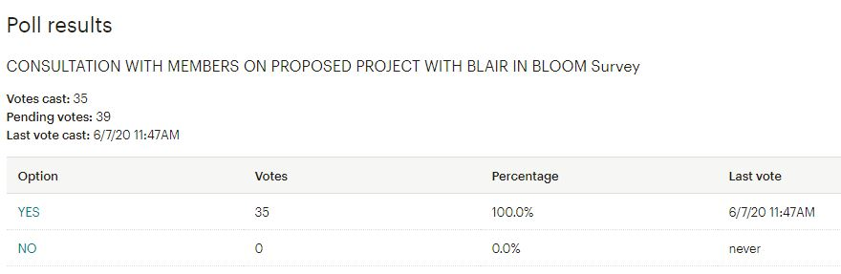



**Online Research:**

This has mostly focused on member organisations and national policy supporting projects that support outdoor learning etc…Blair in Bloom is a member of the following organisations

[Social Farms and Gardens -](https://www.farmgarden.org.uk/your-area/scotland) Social Farms & Gardens is a UK wide charity supporting communities to farm, garden and grow together**.** The vision - people and communities reaching their full potential through nature-based activities as a part of everyday life. Mission - to improve the health and wellbeing of individuals, communities, and the environment through nature-based activities.

[Trellis Scotland](https://trellisscotland.org.uk/about_us) is Scotland’s network for therapeutic gardening. Fieldworkers with expertise visit and support gardening projects across Scotland. Trellis offer information services about a wide range of subjects related to therapeutic gardening - from horticulture to garden project management.

[Scottish Allotments and Gardens Society](https://www.sags.org.uk/library.html) a long established organisation offering excellent free resource and reference materials

[Curriculum for Excellence through Outdoor Learning](https://education.gov.scot/Documents/cfe-through-outdoor-learning.pdf) is designed to help teachers, educators, Community Learning and Development (CLD) and their partners, including the voluntary sector, plan such experiences to ensure that progressive and sustainable outdoor learning opportunities are embedded in the new curriculum

**Scotland eyes outdoor learning as model for reopening of schools**

Outdoor learning could offer a template for socially distanced schooling across Scotland according to practitioners who believe the coronavirus pandemic could push parents and teachers to embrace the benefits of education in the outdoors. The outdoor experience is already a part of Scotland’s “curriculum for excellence”, while many councils have ambitious plans to expand outdoor learning as they meet the Scottish government’s commitment to a near-doubling of funded childcare this year.

[**Guardian Newspaper**](https://www.theguardian.com/uk-news/2020/may/10/scotland-eyes-outdoor-learning-as-model-for-reopening-of-schools) **10th May 2020**

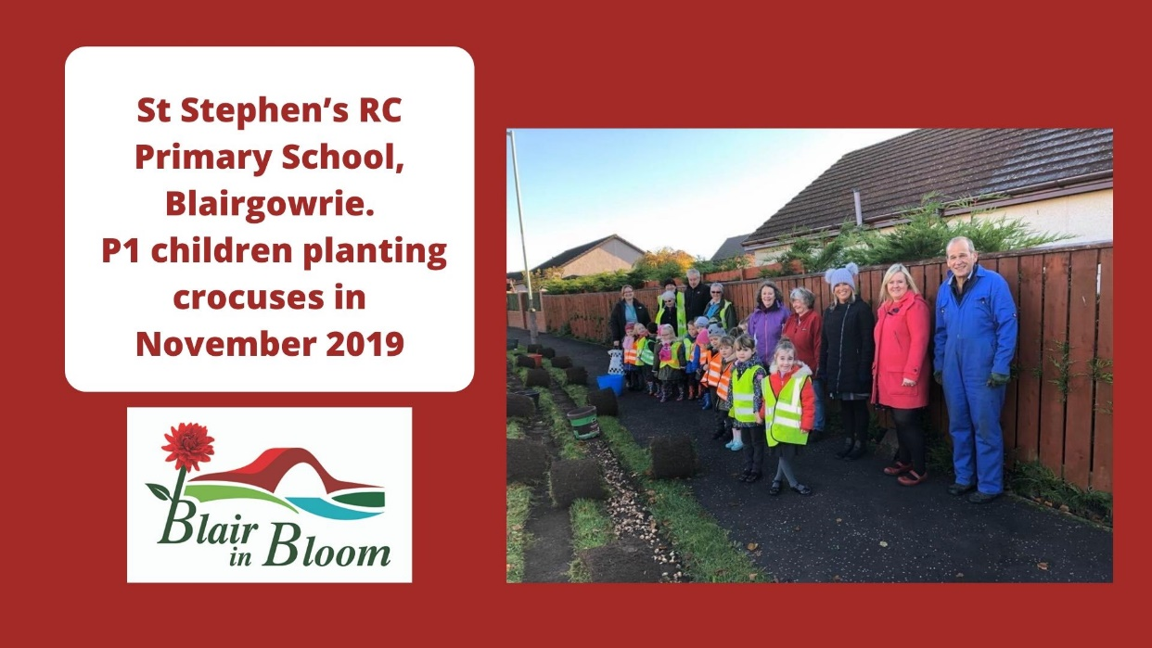

**4.3 Exemplar Community Gardens**

A short survey of exemplar community gardens by email and telephone interview was carried out through May 2020. But for Coronavirus restrictions, visits to these gardens would have been organised.

A short and simple questionnaire was designed to gather information from well-established and successful Scottish community gardens operating in areas with a similar demographic. Seven groups were approached - responses were received from four:

* PLUS, Perth – Horner’s Plot City Garden & Loon Braes (Therapeutic & Ecosystems)
* Coupar Angus Community Garden – partial response
* Lanarkshire Development Trust – Castlepark Horticultural Centre
* Brighter Bothwell

**4.4 Key Findings and Learning Points**

These have informed the Community Garden Implementation Plan in Section 6.2

**Governance and Operational Management Structure**

* **All gardens have a robust committee** overseeing the project. Some are entirely staffed by volunteers such as Bothwell, where others have employed staff for specific purposes such as supporting volunteers, expertise in horticulture, teaching skills and managing development.
* **Staffing** - the Therapeutic Garden found over time that several of the people working in the garden had mental health needs requiring support best met by a specialist support worker. The Horticultural Centre generated income by responding to a demand for gardening courses through employment of an Educational Gardener.

**Engage with the Community**

* **Create a Welcoming and Inclusive Space** Horner’s Plot (formerly an inaccessible derelict and overgrown space) was inspired and developed by PLUS Members and people from the community (often by word of mouth) who wanted to contribute to the project – builders, a stone mason from Pitlochry, a local farmer donating manure! Some members simply come to sit in the garden while others with art skills create attractive signs for the borders etc… the ethos is that everyone brings something valuable into the garden.

**Risks and Responses**

* **Vandalism –** good insurance packages from Royal Horticultural Society
* **Visibility is important** – ensure people can see what you are doing…recommending railed gates
* **Legal Services** may need the services of a lawyer to draw up an agreement whether you are buying or leasing - who is held responsible for any problems which may occur?

**Critical Success factors**

* **Involving the Community** – making friends with neighbours and fostering good relations with people in the area. This definitely improves security as people tend to care a bit more and ‘keep an eye on it’
* **Partnership Projects** understanding community needs. Castlepark started a highly successful Family Gardening Club – parents and children learning together, extremely popular and brings in revenue. Partnership projects with community care groups supporting people with mental health needs, autism – another income generator.
* **Time and Effort** many committee members devote a lot of time to making the garden work well
* **Regular maintenance** sessions provide opportunities for community engagement with a wide range of people of all ages and abilities including corporate volunteers (locally Aviva have this scheme)
* **Unpaid help from people in the community** such as an architect, civil engineer, quantity surveyor, project manager and many others who give their time willingly
* **Corporate Volunteers** are a real benefit to the Castlepark Horticultural Centre. Annually they have a group of between 10 – 20 who come to the garden for a day to help with maintenance tasks/volunteering. Scottish Water offer a lot of support.

**Revenue income streams – Income Generators**

* **Mixed and Opportunistic** mostly grants, donations and fundraisers
* **Corporate Partners** – one exemplar has a mutually beneficial relationship with a local landscaping company who use the site and the training facilities. Local firms undertake staff training and corporate volunteers are a helpful resource – this strengthens relationships with local business
* **Building up Capital** always a good idea to have some money in reserve for unforeseen circumstances.

Full responses can be found in **Exemplar Community Gardens Supporting Documents Appendix F**

**5.0 The Project and Community Asset**

The asset/site is located in Rattray, Blairgowrie between Mount Ericht Road and Balmoral Road. Vehicle access to the site is from Balmoral Road 20 metres north of the junction with High Street Rattray.

The site extends to a size of 0.317 hectares or thereby as indicated on site survey drawing from Caledonian Housing Association and is a flat and level site, previously used as a walled garden. There are no services onto the site, but both Scottish Water and Scottish and Southern Energy have confirmed that there are adequate supplies close at hand.

Blair in Bloom have occupied this site for 10 years under licence from Caledonian Housing and have erected two polytunnels during this time

Another available site in the town was considered but discounted because of the reasons stated here:

**5.1 Site Option Comparison Schedule**

|  |  |  |
| --- | --- | --- |
| **Factors** | **Mount Ericht PH10 7HS** | **Alyth Road Ph10 7HQ** |
| Site Terrain | Site is flat and level ideal for erection of polytunnels and buildings with minimal excavation | Site is north sloping and would require considerable excavation for polytunnels and buildings |
| Site Access | There are two vehicle access points off Balmoral road one shared, one exclusive, both allow vehicle and trailer to negotiate | One shared access point off Alyth Rd, with sharp corners making it difficult for car and trailer to negotiate |
| Site Establishment | BiB currently occupy this site and have two polytunnels erected | Additional cost would be involved in setting up this site with building polytunnels etc |
| Site Establishment Time | This site is already up and running | Additional time would be required to move polytunnels etc |
| Site Cost | Both sites are approximately of the same value | Both sites approximately of the same value |

**Outcome of Site Option Appraisal**

In view of the above information, the decision was made to proceed with the **Mount Ericht Site PH10 7HS**

**5.2 Site Photographs & Planning Map**

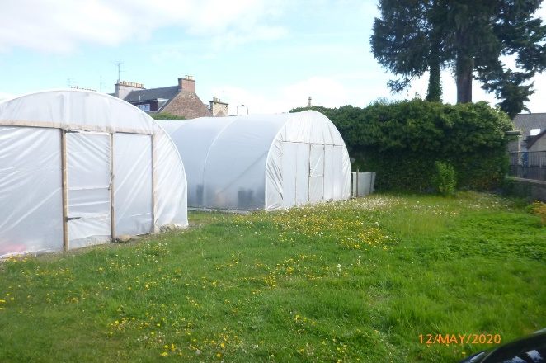 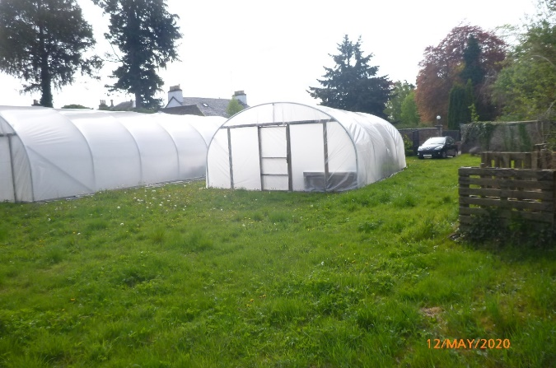 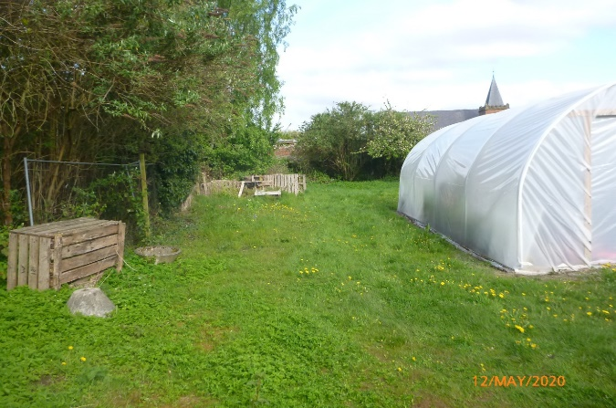 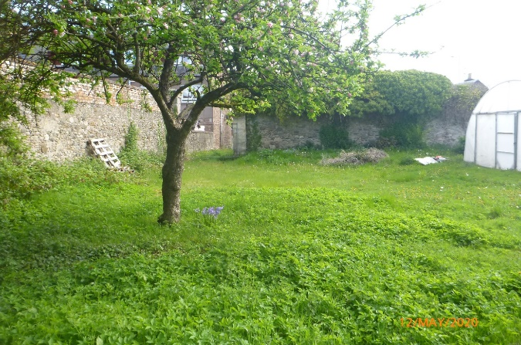

****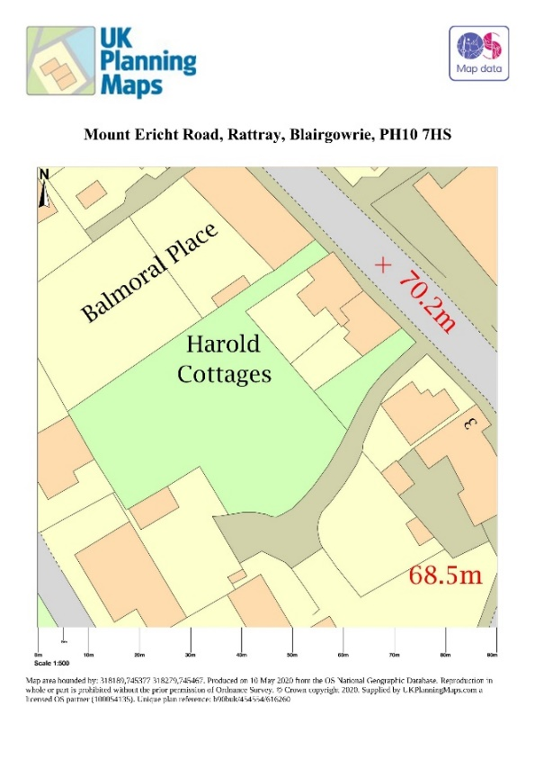

**6.0 Project Objectives**

**Mount Ericht Community Garden Aims & Objectives**

**Aims**

* To secure the land for Blair in Bloom and the wider Community, ensuring the continuation of the valuable work carried out by the volunteers in improving and enhancing the environment for residents and visitors to the town
* To develop a community garden for education, health, and well-being as well as growing fruit, vegetables, and flowers.
* To engage and involve interested groups and individuals to maintain, develop and use the garden, ensuring its long term sustainability

**Objectives**

* Maximise the use of the polytunnels for best value
* Develop and provide a safe and secure environment for education of small groups of all ages and gender and encourage intergenerational activity
* Provide a welcoming, relaxing area where local groups can meet, supporting their health and wellbeing, developing their gardening skills, and observing wildlife
* Develop and maintain an area, including raised beds, to grow fruit and vegetables for those in need
* Provide workshops and short courses on gardening skills
* Encourage and facilitate biodiversity with careful management and planting
* Integrate the garden with other groups in the town. Host outdoor events bringing gardening and the arts together – invite artists, sculptors, poets, and writers of which there is an abundance in the town

**6.1 Community Garden Partners – Groups and schools ‘Signed Up’**

The following organisations have pledged to participate in the Community Garden More information can be found in the completed pro forma see **Supporting Documents Appendix G**

| **Organisation** | **Signed up to ….** |
| --- | --- |
| PLUS, Perth Therapeutic Community Gardens | Sharing resources, equipment, partnership projects |
| Blairgowrie,Rattray and District Climate Cafe | Creating small community orchards, outdoor classrooms for all ages, join the Community Garden Working Group |
| Perth and Kinross Council Community Learning & Development | Outdoor classrooms and Adult learning opportunities, working with youth organisations |
| Strathmore Men’s Shed | Building raised planters, join the Community Garden Working Group, develop a gardening section of the Shed activities |
| *Newhill Primary School | Outdoor classroom, growing plants from seed, vegetable growing in raised beds, therapeutic use and be involved in the Community Garden Working Group |
| *St Stephen’s RC Primary School  [School Eco Committee] | Outdoor classroom, vegetable growing in raised beds, therapeutic use and be involved in the Community Garden Working Group – link to School Eco Committee |
| *St Stephen’s RC Primary School | Outdoor classroom, vegetable growing in raised beds, therapeutic use and be involved in the Community Garden Working Group – an opportunity to involve children in designing the project and what they could bring to it. Whilst unable to meet…could be an activity for them to think about as part of current online learning activities |
| Rattray Primary School | Outdoor classroom, growing plants from seed, vegetable growing in raised beds and therapeutic use, such as a sensory garden and be involved in the Community Garden Working Group |
| Strathmore Centre for Youth Development | Involvement in a range of activities as agreed between young people and the Garden and be involved in the Community Garden Working Group |
| Pop Up Art Room Blairgowrie | Outdoor classroom, growing plants from seed  Therapeutic use e.g. Sensory garden, Pop Up Art Room education through Art; creativity and citizenship, creative learning opportunities, outdoor learning with children and families, exploring nature, plants and flowers through art and creativity and be involved in the Community Garden Working Group |
| Hamish Matters | To use the site for small events, such as poetry readings, storytelling, acoustic music sessions, art installations, interactive creative events all relating to Blairgowrie born poet and songwriter Hamish Henderson. A weeklong Festival runs each November to celebrate the life of Hamish Henderson, during which outdoor events have previously taken place. |
| Perthshire Wildlife | Outdoor classroom, growing plants from seed,  Therapeutic use, such as a sensory garden, involve groups such as Brownies, Guides, Cubs, Scouts etc. Engaging people with managing the site for wildlife and be involved in the Community Garden Working Group |

**\*St Stephens Roman Catholic School and Newhill Primary Schools are located on the same Community Campus**

**6.2 High Level Implementation Plan with Measurable Outcomes 2021-2025**

**[Subject to Coronavirus Restrictions]**

Works will entirely depend on the restrictions of the Coronavirus and the eventual loosening of the rules and social distancing. There will continue to be difficulties consulting with other groups due to the Coronavirus situation.

| **Timescales** | **Activity** | **Outcomes** |
| --- | --- | --- |
| **Oct - Dec 2020 on completion of land sale** | Establish a Management Committee for the Community Garden | Robust governance and management structures |
| **Year One**  **Oct 2020**  **To**  **Sept 2021** | Complete Operating and Performance Framework, insurances, all required Policies, Health and Safety Plan and Risk Register | Compliant and effective governance framework is supporting current and new activities |
| Clear site, secure the perimeter, put in services, provide seating, a toilet, storage facilities and Construct raised beds | A secure site that is fit for purpose to support planned activities |
| Engage with and retain the interest of ‘signed up groups’ including them where possible in the work to secure and prepare site | Retention of interested partners and stakeholders in the Community Garden Project |
| Continue Blair in Bloom normal operations in existing polytunnels on site and across the town | Blair in Bloom Business Growth Plan in Operation |
| If required - run a volunteer recruitment programme to ensure resources and capacity meet the twin demands of continuing normal operations alongside development work | Continuous project delivery with sufficient capacity and resources |
| **Year Two**  **Oct 2021**  **To**  **Sept 2022** | Review and refresh financial plan for 2022 to 2025 including identification of any new potential funding streams | Financial sustainability, diversified funding mix, surpluses/reserve for general contingency in situ |
| Assess any benefit to establishing a new legal framework – review option to establish a social enterprise or community interest company | The Community Garden maximises its income |
| Review volunteer workforce needs including induction, training, and support programmes | A satisfied and fulfilled volunteer workforce that feels valued |
| Review any emerging requirement to employ paid staff, seek and apply for funding and recruit | Resource and capacity needs of the Community Garden are fully met by workforce |
| Assess learning and induction needs of new user groups on site – plan and develop programme | Site users are competent, safe, and compliant in delivery of all activities |
| Establish agreements and schedules to bring in partner groups, schools etc on site | A yearlong operating programme of activities |
| **Year Three**  **Oct 2022**  **To**  **Sept 2023** | Review (Digital) Marketing and Communication Plan | Active and engaging website and social media with increasing followers |
| Annual review and refresh financial plan for 2022 to 2025 including identification of any new potential funding streams | Financial sustainability, diversified funding mix, surpluses/reserve for general contingency in situ |
| Subject to outcome of Year Two Assessment of legal framework – establish structure of new organisation | The Community Garden maximises income and increases sustainability |
| **Year Four**  **Oct 2023**  **To**  **Sept 2024** | Conduct Year Three full performance review including all partners on site and wider stakeholders – refresh and produce Draft Development of Community Garden Business Plan 2024 - 2027 | The Community Garden meets the identified needs and aspirations of the town, its residents, and visitors |
| Annual review and refresh financial plan for 2022 to 2025 including identification of any new potential funding streams | Financial sustainability, diversified funding mix, surpluses/reserve for general contingency in situ |
| **Year Five**  **Oct 2024**  **To**  **Sept 2025** | Consolidate and launch Community Garden Business Plan 2024 - 2027 | The Community Garden is financially sustainable and meets the needs of the community |

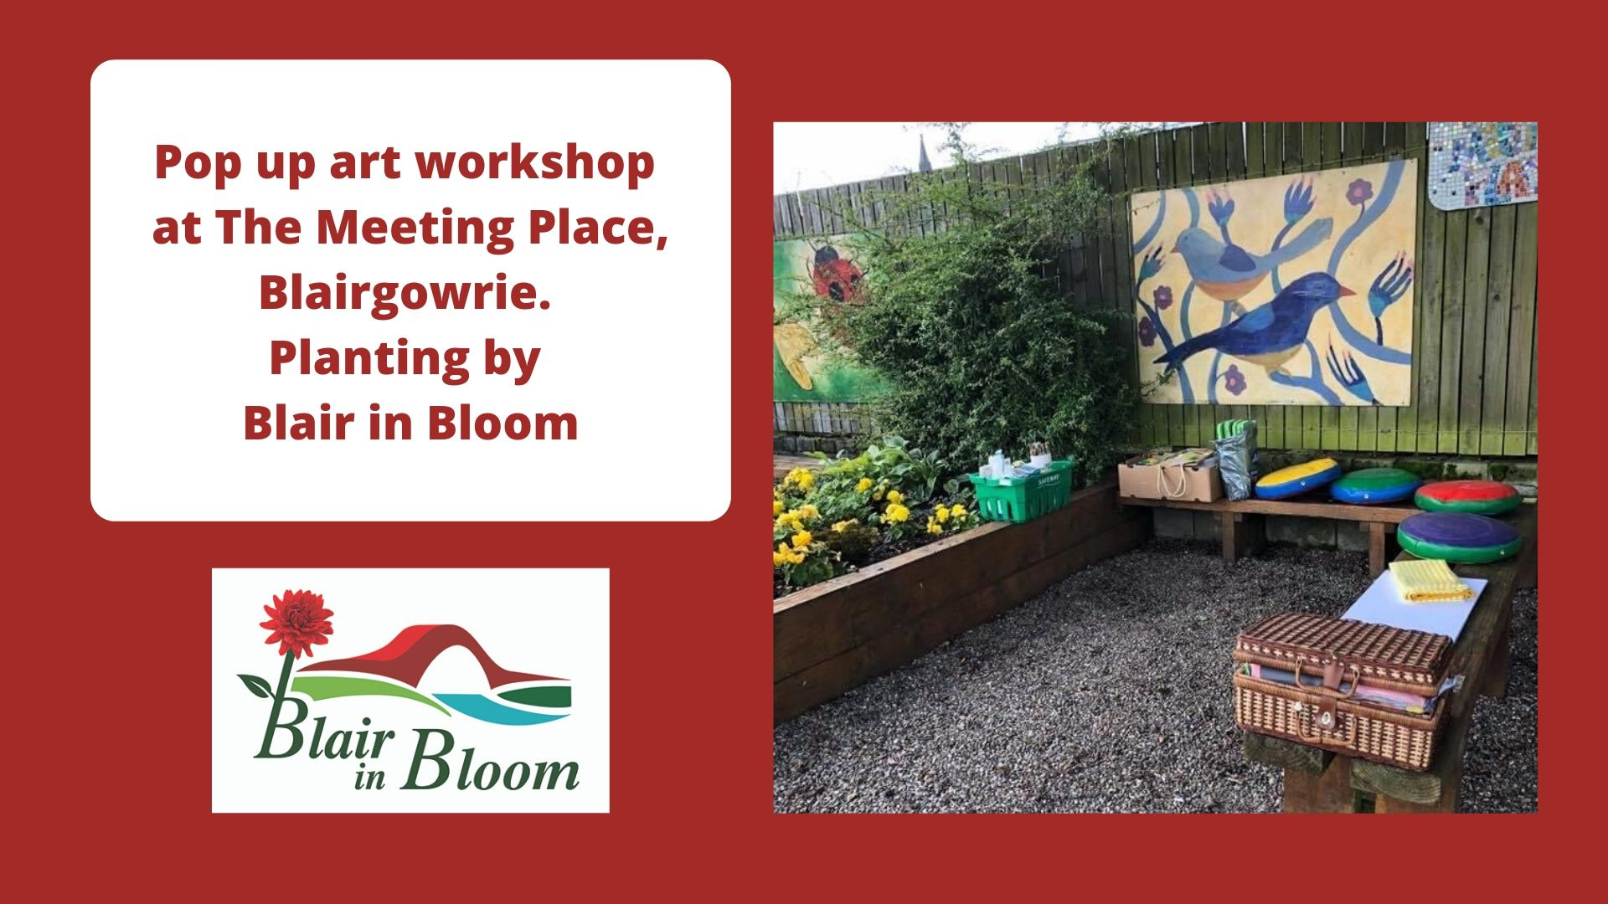

**Bringing Art and Gardening Together**

**6.3 Project Resources - Input from Partners and Stakeholders**

Blair in Bloom and Mount Ericht Community Garden will remain members of The Trust Support Programme and therefore continue to have access to services and guidance for the development of the project. A Management Committee will oversee the implementation of the Business Plan with support and help from The Trust and will also include those groups who have pledged to use the site and join the collective effort to realise the plans for the garden. Themed sub-groups will be formed as required to take forward specific workstreams.

**6.4 Recruitment and Training Plans**

As per the Implementation Plan, a review of the volunteer workforce including induction, training, and support programmes will be undertaken in Year Two. By this point activity levels on site will be better known and this may necessitate a workforce review of any requirement to employ paid staff. This will also be the time to assess and formulate induction and training needs of new user groups on site.

**6.5 Impact on Existing Blair in Bloom Work**

The work of the group has been drastically curtailed during Coronavirus. However, some of the beds and containers have been planted by community members not ordinarily involved which demonstrates a really positive response and ‘helping hand’ out there.

When Mount Ericht Community Garden goes ahead, the Implementation Plan in Year One sets out the requirement to draw up a simple **Business Growth Plan.** The plan will include an **Impact Analysis** withto respond to any challenges that may arise.

| **Critical Activities** | **Potential Impact of Growth** | **Improvement Actions** |
| --- | --- | --- |
| Production of hanging baskets for sale to local businesses and public - important revenue income | Reduced production capacity due to volunteers being diverted to other activities | Recruit additional volunteers and support from groups signed up to participate in the garden  Consider increased involvement of Community Payback  ‘Borrow’ volunteers from partner groups (BRAN)  Recruit new corporate volunteers, large local employers eg Castlewater  Bring forward recruitment of paid employee |
| Install usual floral displays in beds and containers across the town | Reduced production capacity due to volunteers being diverted to other activities |
| Progress the high profile improvement project at Coronation Corner, complementary planting alongside artist mural on a prominent town centre site | Reduced production capacity due to volunteers being diverted to other activities |
| Ensure the site at Mount Ericht is safe and secure | Unforeseen repairs or work required to ensure site safety | Increase reserves to mitigate. Launch an additional fundraiser jointly with signed up groups |

**6.6 Volunteer Resources**

The addition of the Mount Ericht Community garden to the Blair in Bloom portfolio will extend operations considerably. Whilst difficult to quantify precisely in terms of increased volunteer hours, the development will take place over a five year period thus allowing time and a degree of flexibility to respond to any recruitment, retention and operational management challenges.

**6.6.1 Current Volunteer Team**

There are twenty seven active volunteers covering all meantime activities including fundraising. It is only feasible to estimate addition resource demand in Year One.

**Additional Volunteer Resource Year 2020-2021 is estimated as follows**:

**Committee Year One:** complete operating and performance framework, all additional policies, full health and safety plan and risk register **= 70 to 90 hours**

**Core Volunteer Workforce:** will continue usual Blair in Bloom activity

**Additional Volunteers:** Strathmore Men’s Sheds offered to build the raised beds; SCYD youth volunteers have offered general support. It is highly likely other groups such as Blairgowrie Access Network will offer help.

**6.6.2 Trust Project - Volunteer Coordinator Post for the Town** - through its work in coordinating and taking forward the Community Action Plan, the Trust recognised a need in the area to employ a Volunteer Coordinator with a development role to progress a town-wide strategic approach to strengthening the infrastructure and supporting networks for volunteering in the future. The Trust has applied for funding to support this post for a period of three years. A decision will be known before July 2020. If successful, a key priority of the Volunteer Coordinator will be to support Mount Ericht Community Garden with volunteer resource needs.

Coronavirus has seen a huge upsurge in the numbers of people volunteering in the town. Whilst some of those will return to work, an initiative of the local Coronavirus Coordination Group is underway to retain as many as possible beyond this period and to increase the pool of potential volunteers.

**6.7 Policy Audit**

The Trust has all necessary policies in place to cover financial governance, staffing, volunteering, health, and safety and GDPR. Blair in Bloom also has policies in place including Child Protection, Volunteer Policy etc.

**7.0 Project Costs - Financial Analysis**

The spreadsheets detail the projected income and expenditure and the total funding required with the anticipated expenditure of period.

Sheet 1 Expenditure Plan Running Costs 5 years

Sheet 2 Income Plan 5 years

Sheet 3 Total Capital Funding Raising and Expenditure Plan

Sheets I and 2 are based on Blair in Bloom experience gained over the years from fund-raising efforts and actual expenditure.

The 2019/20 column on these sheets is based on actual earnings and expenditure for the last 12 months prior to February 2020. The reason for including this is to demonstrate previous level of income and expenditure and to highlight the cash adjustments made to cater for the effects of Covid 19 on the income and expenditure

**7.1 Expenditure Plan – 5 Years Running Costs**



**7.2 Income Plan 5 Years Projection**



**7.3 Total Capital Fund Requirement**

**7.4 Prospective Staffing Costs**

Should it be necessary to employ a member of staff in Year Two, grant funding will be sought as it will be too early for any income generation to meet salary costs. Indicative costs are:

**Community Garden Project Officer**

Salary £25,000.00

On costs NIC, Pension, salary admin etc 30% £7600.00

Travel expenses £2000.00

Office rental cost £400.00 Per Annum

Making total of £3500.00 Per annum

**7.5 Costs to The Trust**

Commercial property with £5,000,000 public liability is quoted at £336 per annum.

**8.0 Community Garden - Funding Plan 2020-2025**

This Plan describes how the Committee of Blair in Bloom will finance both current and ongoing activities including the new project at Mount Ericht Community Garden. Its key purpose is to ensure that core work is maintained, and the group makes effective use of all financial support received.

The Plan looks at where Blair in Bloom is now, where it aims to be in three to five years’ time and what strategies will be needed to achieve sustainable finance. The Committee will review the strategy annually.

The overarching aim is to build organisational capacity of Blair in Bloom to ensure it is also capable of delivering the planned Community garden at Mount Ericht

**8.1 Fundraising Activities**

These take place throughout the year and are operated by the volunteers of Blair in Bloom. Over the last 20 years these income sources have proven to be reliable, giving a stable source of income which clearly demonstrates the strength of support the group has from the local community:

* Spring and Christmas raffles in local supermarket
* Pop up shop in vacant local unit Howes selling clothing & household goods donated by the local community
* Annual sale of hanging baskets to local businesses
* Annual sale of hanging baskets to public
* Annual sale of plants to public
* Social quiz night at Rattray Bowling Club
* Donations from local residents
* Donations from Robert Smith Groundworks Contractor
* Donations from Kirkview Garage
* Donations from local groups Lyric Choir, Rotary Club and BRAN (Blairgowrie and Rattray Access Network
* Just Giving*

Blair in Bloom has applied for and been successful in receiving grants from the following organisations:

* Annual grant received from Perth & Kinross Council Greenspace
* Community Environment Challenge Fund
* Community Investment Fund*
* The Gannochy Trust*
* Tesco Bags for Help*
* Awards for All*

*\*This funding is ring-fenced for the Coronation Corner project*

Blair in Bloom consider fund raising not as a one-off event but a continual on-going exercise and are always looking for means to raise funds. Future funding ideas being investigated include:

* Sponsorship for garden and sitting areas in the town
* Pavement furniture planter’s sponsorship
* Machinery and hand tools sponsorship
* Crowdfunding
* Funding opportunities through social media pages
* Online donations through website (in development)

**Continuous search for suitable funding organisations**

[The Mushroom Trust](https://mushroomtrust.com/about/)

The primary goal of the Trust is to support the creation and improvement of greenspaces, particularly in urban environments, through an emphasis on horticultural aspects. In recent years the Trust has supported a broad variety of proposals for the improvement of… the planting of community gardens and orchards, and the creation of therapeutic garden spaces.

[National Lottery Awards for All](https://www.tnlcommunityfund.org.uk/funding/programmes/national-lottery-awards-for-all-scotland) offers funding from £300 to £10,000 to support what matters to people and communities. The programme is a partnership between the Big Lottery Fund Scotland, sportscotland and Creative Scotland.

National Lottery Awards for All has three funding priorities – Mount Ericht Community Garden could address the following:

* Bring people together and build strong relationships in and across communities
* Improve the places and spaces that matter to communities

[Aviva Community Fund](https://www.aviva.co.uk/services/more-from-aviva/aviva-community-fund/) social change and stronger communities . Corporate volunteers from Aviva workforce

**Framework for the Funding Plan** - **Classifications of Activities**

**Core Activities** which must be continuously provided to fulfil the core purpose of the group. These form the highest priority for financing and include:

* Continuation of longstanding border/container planting programme across the town
* Provision of hanging baskets to businesses and general public
* Progression of the project at Coronation Corner
* Support and sustain an effective and fulfilled volunteer workforce

**Growth Plan**

* Work with partner groups and schools on the Mount Ericht Community Garden

**Classification of Income**

|  |  |  |
| --- | --- | --- |
| **Activity** | **Current** | **+ Plus Mount Ericht** |
| Retailing Income | Sale of hanging baskets and plants | Foundation Gardening Courses, plot fees, hosting events |
| Project Funding (Restricted shorter term) | Coronation Corner Fund Secured in total | To be identified as operating model develops |
| Grant Income (Restricted) | As in Section 8.1 | Grant Funding Paid Employee Year Two to Five |
| General Fundraising – (Unrestricted, shorter term) | Howes pop-up charity shop spring and autumn, quiz night and raffle January, Tesco raffle spring and winter | Potential – lease of raised beds and plots. Host fees for events and activities, training events and partnership projects |

**Blair in Bloom will seek to achieve financial sustainability by:**

* Maintaining a diversified funding mix, with a solid block of core/retail financing and project funding to cover key activities
* Generating modest surpluses through general fundraising to build and maintain a reserve for unexpected expenses and general contingency planning
* Annual budget to include a specified amount each year to be put aside for the reserves fund

**9. Financial Analysis**

The following is a five year projection displaying a running surplus over this period.  Figures are shown for what costs are expected to be incurred regarding the land purchase and development in years 2021-2023. This shows the shortfall and what is needed to develop the land compared to the surplus that will be generated by the organisation.



**10.0 Marketing and Communication**

Blair in Bloom has links with most parts of the community and has been an established part of the local infrastructure for 42 years. It is a much respected voluntary organisation operating at the very heart of the town, enjoying considerable support from the community and other organisations.

The Blair in Bloom team issues regular press releases for the local [10]Blairgowrie Advertiser and the [11]Hub Magazine - a quarterly publication produced by Blairgowrie & Rattray Development Trust and delivered to more than 4500 households in the town.

Blair in Bloom has a Facebook page ‘Blairinbloom’ which is updated frequently with posts and photographs and a twitter account @Blairinbloom where they regularly communicate with groups all over the UK via the hashtag #bloomhour, sharing information on projects, planting, etc.

See Survey Monkey Report Supporting Documents Appendix A for evidence of how well thought of the organisation is)

**Perth & Kinross Council**

**Partner Voluntary Organisations**

**Community Action Plan Groups**

**Blairgowrie & Rattray Development Trust and Blair in Bloom**

**Local Community Stakeholders Childcare facilities, Schools, Youth Services and Older People’s Support Services**

**Tourism and Local Business -Local Shops, Restaurants, Hotels**

**Marketing help can be provided through The Trust Community Support Programme**

* Website content
* Social media
* Public Relations – press releases, communications with press and media

**Potential Markets**

Organisations who have pledged support and signed up to participate in Mount Ericht Community Garden

* Community Education - Perth & Kinross Council
* St Stephen’s Roman Catholic Primary School
* Rattray Primary School
* Newhill Primary School
* Strathmore Men’s Shed
* Strathmore Centre for Youth Development
* PLUS Perth & Kinross – Horner’s Plot and Loon Braes
* Pop Up Art Room Blairgowrie
* Perthshire Wildlife
* Blairgowrie & Rattray Climate Café
* Hamish Matters

**Target Market**

* Blairgowrie and Rattray community as a whole.
* Those who live within a 30 minute or less travel distance
* Inclusive of all ages, abilities, gender and background

**Target Audience**

**Community Groups** - there are around 40 known Community Groups in Blairgowrie & Rattray. Examples of these **not yet signed up** who could use the Community Garden are:

* Blairgowrie & Rattray Time Bank
* Blairgowrie Community Market
* It’s BRAW Arts Festival
* Blairgowrie & Rattray Illuminations Committee
* Rattray & District Scottish Women’s Institute
* Wisecraft – Mental Health

**Nurseries & Schools**

* Rattray Nursery
* Blairgowrie High School
* Cornerstones Children’s Nursery (private)

**Care Homes**

* Balhousie Stormont Care Home
* Beech Manor Care Home
* Northlands Care Home
* Muirton House Care Home

**Sheltered Housing**

* Harriet Court Sheltered Housing
* Bield Housing Association
* Caledonia (Supported) Housing
* Cairn Housing Association
* Ashgrove Court

**Businesses & Enterprises**

* Producers, restaurants, caterers, and growers.
* Health & Wellbeing Supports Services
* Events, storytellers, musicians eg It’s BRAW Blairgowrie & Rattray Arts for Wellbeing, Lindsay Storyteller
* Arts & Crafts Groups e.g. [NEST](https://www.nestcreativespaces.co.uk/) Creative Spaces CIC who ‘yarn bombed’ the Blair in Bloom Ruby Jubilee Display

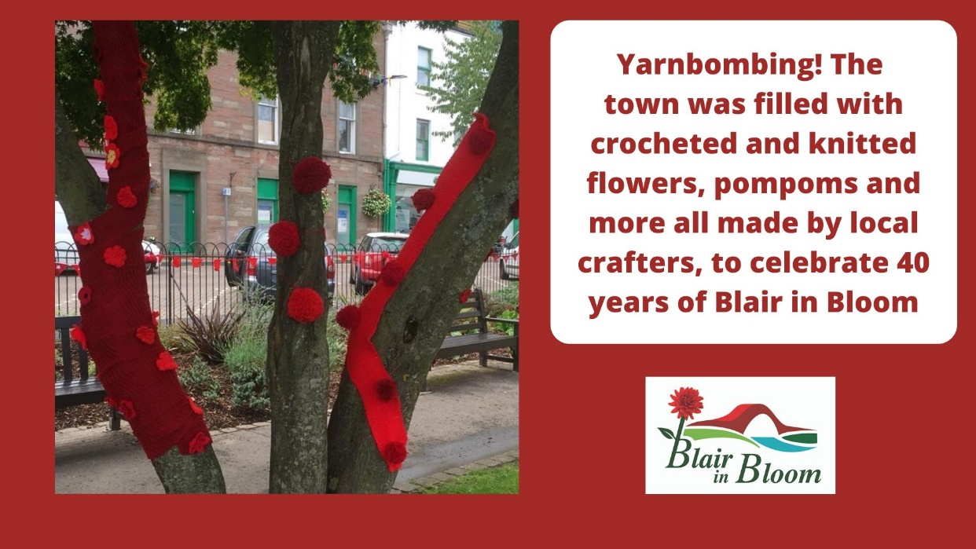

**Communication Platforms**

* **Local & Wider Press** – Blairgowrie Advertiser, Courier, Perthshire Advertiser and Evening Telegraph.
* **Hub Magazine** - delivered quarterly to 4500 houses in Blairgowrie & Rattray
* **The Trust Website**
* **Social Media** – Facebook, Twitter…Consider an Instagram Account
* **Discover Blairgowrie –** community information website
* **Videos and Slideshows –** display at libraries, doctors’ surgery, on website and social media
* **Posters and Flyers –** numerouscommunity noticeboards in town, on buildings and businesses
* **Identify other publications** eg Perthshire Magazine, Alyth Voice
* **Via other partner organisation websites and newsletters**  eg Discover Blairgowrie, GrowBiz Perthshire
* **Mailchimp**  - Established database to be developed with regular updates.
* **Media** – BBC Scotland, STV, Radio Scotland, Radio Tay, Wave FM, Heartland Radio. Landward, Scotland Outdoors
* **Events –** attend events held by relevant groups and organisations to give talks and information.
* **Local Businesses** - ensure awareness through active links with the business association
* **Potential (Corporate)Sponsors** to be followed up
* **Local “celebrities”** endorsement
* **Other**  Perth & Kinross Action for Voluntary Service – Third Sector Interface

**Marketing the Product**

* Pop up events to promote Community Garden both now and once functional. could take place in local businesses eg café, library
* Making use of the public to assist in the maintenance of the garden – skills development of employability opportunities/skills development
* Support local economy by employing local tradespeople.
* Video recording timeline of the progress of the garden once purchased, providing a legacy for the town
* Adopt ethos of upcycling and reusing…circular economy, building on the well-established links with Climate Café.
* Abilities explore accessibility for disability groups and wheelchair users

**Mount Ericht Community Garden Marketing Actions and Outcomes**

| **Actions** | **Outcomes** |
| --- | --- |
| **2020**  Blair in Bloom website under construction  Announcements of funding success in local press and social media channels.  Followed by ongoing social media updates and press releases at newsworthy points.  Use time to build up website collateral | **2020**  Increased awareness  Increased social media following  Start to drive traffic to new website |
| **2021**  **Site Clearance Year**  Press release to announce start of work and thereafter at ongoing newsworthy points  Images and video records of site clearance to be taken  Ongoing Social Media posts recording journey of the site clearance.  Page on website documenting the progress of the sight – links on social media to drive people to the website which will also contain information about other projects and work being carried out by Blair in Bloom. This will also create a legacy piece  Ensure continuing engagement with community and community groups through Community Action Plan and Trust Forum | **2021**  Increased awareness  Increased social media following  Engagement on website  Anticipation of community garden official opening  Strengthen links with community groups ahead of opening |
| **2021+**  Booking calendar to be added to website for usage of garden  Marketing in press, on social media and other relevant websites  Regular updates to website, possibility of blogs, guest pieces, embedding of videos, podcasts  Ongoing social media to raise awareness and drive traffic to website  Ongoing consideration of possibilities for use of garden and engaging with potential new users and audiences | **2021+**  Awareness of garden, who can use it, how to book to use it.  Sustainable systems in place through website for management of garden  Continued promotion of garden to engage ongoing and new users |

**11.0 Risk Analysis**

In addition to this Risk Management Plan, the Business Growth Plan (Section 6.5) identifies a number of potential impacts on current activities which can also be considered risks. Improvement actions are also set out in that plan.

| **Potential Risk** | **Mitigation** |
| --- | --- |
| Scottish Land Fund Application is unsuccessful | The Trust will work with Blair in Bloom to research alternative means of funding in the interim between 12th June and decision time to enable immediate switch  The Trust will advise and discuss with Caledonia Housing Association the prospect of this scenario arising and request continuing security of tenure until funds are secured. This is likely to be acceptable since the lease has run for ten years unhindered. |
| Coronavirus restrictions do not ease prior to acquisition of community asset | Adjust timescales and milestones within the Implementation Plan.  Ensure all partners and stakeholders remain informed about the situation through newsletter, social media, and press release to retain interest and commitment |
| Sources of revenue funding stop or reduce | The Trust Development Team and Finance Manager will work with Blair in Bloom to identify alternative income generators, fundraisers, and grants  Financial review will be undertaken at each meeting of the committee – a standing item |
| Vandalism and Theft | Good insurance packages are available from Royal Horticultural Society  Visibility is important – ensure people can see what is in the garden…recommend railed gates. This encourages neighbours to take an interest and ‘keep an eye on things’  Installation of Solar Powered CCTV |
| Incidents and Accidents | Ensure all volunteers and site users working in the garden have read and signed the health and safety manual and risk management plan  Site users are competent, safe, and compliant in delivery of all activities – mandatory to complete full induction and training programme before working on site  Maintain accident and incident logs – taking remedial action after each event  Monthly checks (or as required of equipment and known hazards)  Public Liability insurance in place up to £5,000,000 |
| Lack of clarity about mutual responsibilities and liabilities between The Trust and Blair in Bloom | Legal services to draw up an agreement setting out who is responsible for any problems which may occur  Clear and unequivocal insurance policies setting out mutual responsibilities |

1. **Monitoring and Evaluation**

**The Community Garden Implementation Plan** will provide a strategic focus and guide the work of the Community Garden Management Committee; ensuring the project remains well directed and outcome oriented. All outcomes will be measurable to enable effective evaluation.

**Governance and Management Framework** Mount Ericht Community Garden will be developed and overseen by a Management Committee comprising Blair in Bloom Chair and two other representatives with appropriate skills, the Trust Development Officer, Trust Finance Manager and representatives of key stakeholders/groups signed up to participate in the project.

**Blair in Bloom Committee**

**The Development Trust Board**

**Community & Funding Stakeholders**

**Inputs Community Action Plan Working Group**

**Community Garden Management Group**

**Development, Marketing Operation, and Performance Monitoring**

**Themed Sub Groups …as Required**

**Year One Site Clearance Monitoring**

**Community Garden Performance and Improvement Framework**

| **Outcomes** | **Performance Measures** | **Improvement Actions** |
| --- | --- | --- |
| Robust governance and management structures | Annual review of Management Committee performance by self-assessment | Ensure management committee members have all necessary skills/knowledge – recruit for gaps  Free self-assessment templates are available |
| Compliant and effective governance framework is supporting current and new activities | Twice yearly review of implementation Plan target milestones and outcomes | Review and refresh implementation plan as changes develop and different responses are needed |
| A secure site that is fit for purpose to support planned activities | Incident and accident log – compliance levels with site risk management plan  Review records of meetings with site users | Where necessary, convene a site user meeting to review and report to management committee – highlighting any resource or other issues affecting smooth running of the site |
| Retention of interested partners and stakeholders in the Community Garden Project | Review records of meetings with site users  Monitor activity levels on site and  Levels of engagement and attendance at events  Social media following | Review marketing and communications plan – making changes where required  Survey users and stakeholders – invite suggestions and remain customer focussed |
| Blair in Bloom Business Growth Plan Section 6.5 in Operation | The Growth Plan has impact measures | Improvement actions for all negative impacts are in the Plan Section 6.5 |
| Continuous project delivery with sufficient capacity and resources  Resource and capacity needs of the Community Garden are fully met by workforce | Site activity records/weekly logs, complaints records and notes of meetings with volunteers and site users | Standing item exception reports to Management Committee – workforce and operating reviews, volunteer recruitment – consider a paid post of Community Garden Project Worker – grant funded |
| Financial sustainability, diversified funding mix, surpluses/reserve for general contingency in situ  The Community Garden maximises income and increases sustainability | Income and expenditure accounts  Financial Analysis – five year projections  Budget vs. Actuals Variance Analysis  Cash flow statements | Financial review will be undertaken at each meeting of the committee – a standing item  Annual budget to include a specified amount each year to be put aside for the reserves fund  Generate surpluses through general fundraising to build and maintain a reserve for unexpected expenses and general contingency planning  Where appropriate The Trust Finance Manager will support the Committee to identify trends, budgeting alterations, alternative income generators, fundraisers and grants if required |
| A satisfied and fulfilled volunteer workforce that feels valued | Volunteer appraisal records  Complaints & Compliments records  Notes of meetings with volunteers  Retention rates | Hold focus groups with volunteers  Ensure all volunteers have a personal supporter/mentor responsible for their welfare and wellbeing  Develop and implement a comprehensive learning and development programme for volunteers using Volunteer Scotland templates |
| Volunteers and site users are competent, safe, and compliant in delivery of all activities | Incident and accident log – compliance levels with site risk management plan  Review records of meetings with site users | Ensure all volunteers and individuals working in the garden have read and signed health and safety manual and risk management plan  Ensure site users are competent, safe, and compliant in delivery of all activities – mandatory to complete full induction and training programme before working on site |
| A yearlong operating programme of activities  The Community Garden meets the identified needs and aspirations of the town, its residents, and visitors | Review Community Garden Weekly Schedule and Diary of Events  Periodic Survey of garden users, partners, stakeholders, and wider community – online and paper copies of surveys in key locations, library, Booklore Community Office, Community Connect | The Community Garden Marketing and Communication Plan (Section 10) has a number of approaches to increase engagement and interest in the garden  Management Committee annual review of Marketing Plan |
| Active and engaging website and social media with increasing followers | Google Analytics  Social Media Dashboards  Likes and Shares  Audience Growth/Rate of Followers | Ensure Website is regularly checked for out of date content and refreshed  Increase posting rates aligned with brand messages  Monitor engagement for match with target audience/demographic (The Trust can offer support with this) |

1. [The Local Action Plan – Eastern Perthshire](https://www.pkc.gov.uk/media/41607/Eastern-Perthshire-Local-Action-Plan/pdf/Eastern_Perthshire_Local_Action_Plan.pdf?m=636559317352630000)
2. [Blairgowrie & Rattray Community Action Plan](https://www.brdt.org.uk/blairgowrie--rattray-community-action-plan.html) – Blair in Bloom is an active Working Group Member
3. [Local Action Plan Eastern Perthshire](https://www.pkc.gov.uk/media/41607/Eastern-Perthshire-Local-Action-Plan/pdf/Eastern_Perthshire_Local_Action_Plan.pdf?m=636559317352630000) (Community Planning Partnership – Perth & Kinross Council)
4. [Federation of City Farms and Community Gardens](https://www.farmgarden.org.uk/system/files/scotlandschoolscasestudies.pdf) Two Case Studies – Community Gardens and School
5. [Outdoor Learning Strategy Scotland](https://education.gov.scot/Documents/cfe-through-outdoor-learning.pdf) – Curriculum for Excellence
6. [The Local Action Plan – Eastern Perthshire](https://www.pkc.gov.uk/media/41607/Eastern-Perthshire-Local-Action-Plan/pdf/Eastern_Perthshire_Local_Action_Plan.pdf?m=636559317352630000)
7. Community Anchor Organisations - [Definition](https://scottishcommunityalliance.org.uk/about/anchor-orgs/)
8. **Community Anchor Organisations**: A term first coined in 2004 in a UK Home Office report  – Firm Foundations a concept underpinning the developing national policy discourse around community empowerment renewal of local democracy. 
9. [BRDT Community Support Programme](https://www.brdt.org.uk/supporting-community-groups.html)
10. Blairgowrie Advertiser – [the local newspaper](https://www.facebook.com/Blairgowrie-Advertiser-176924308992290/) published weekly
11. [Blairgowrie & Rattray Hub Magazine](https://www.brdt.org.uk/hub-magazine.html) – produced by the Development Trust