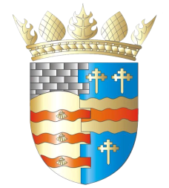
BLAIRGOWRIE AND RATTRAY COMMUNITY COUNCIL

ORDINARY MEETING
Thursday 6th August 2020 at 7pm
Via Zoom

AGENDA
Welcome & Apologies: - Chair
Apologies from Caroline Shiers
- B&R Coronavirus Coordination Group update
- Subjects raised by members of the public.
  - Cutting of verges petition
- Police and Fire Reports.
- Sub-committee updates:
  - Citizen of the Year
  - Xmas tree
  - Bonfire night
  - Resilience Team
- Berries and Cherries Bed
- Bendochy telephone box
- Blairgowrie telephone box and defibrillator
- Treasurer’s report – RD
- Local Councillor’s reports
- Pending Planning Applications
- Planning session for councillors
- Roads, parking and crossing issues
- Spaces for people update
- Litter picking initiative
- Culture Perth & Kinross Covid-19 Collecting Project
- Community feedback
- Future meetings: physical or virtual, when do we return to “normal”?
- AOB
Next meeting – 3rd September 2020 @ 7:00pm. Meeting via Zoom.

