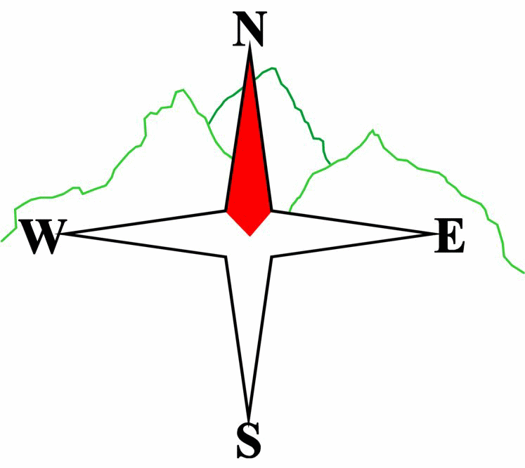
Blairgowrie & District Hillwalking Club

Web site: www.bdhc.org.uk

Ben Vrackie

O.S. Map 52 & 53
11th April 2021

Car meet: | Meet at Ben Vrackie car park above Moulin 10:00am

A Walk – Ben Vrackie
Start at the Moulin car park at NN 945.598, follow the well-trodden path N towards Ben Vrackie, ignore the track that forks off left after 1 1/2kms and strike NE between Meall Aodainn Moire to the left and Creag Bhreac to the E. Pass Loch a Choire to the left and on up the largely stepped path to the summit of Ben Vrackie (C) at 951.633. From the summit, track W and walk down the hill’s western then south western flank over rough heathery terrain. Once on the flatter area around 942.630, strike S then SW to pick up the path to the N of Maell Aodainn Moire, following it until it meets the normal route at 952.614, follow this S and back to the start.

Approx. distance: 9 km |  | Total ascent: 713 m |  | Min. walking time: 4.0 hrs

B Walk – Ben Vrackie – shorter
Start as the A walk to the summit of Ben Vrackie and retrace the route back to the start, perhaps detouring round the shore of Loch a Choire
Approx. distance: 8.3 km |  | Total ascent: 636 m |  | Min. walking time:3.5 hrs

C Walk – Craigower
Start as A & B routes at the Vrackie CP or from Moulin itself, follow the road through the village heading W to Balnacraig 935.595 on the golf course and joining the route of the ancient north road to Killiecrankie. This leads into the Craigower woods (SNT) follow the zig-zag path up to its summit 925.604 and panoramic views. Reverse the route back to the start.
Approx. distance: 7.9 km Total ascent: 320 m Min walking time: 2.5hrs

Approx. distance: km |  | Total ascent: m |  | Min. walking time: hrs

IMPORTANT: YOUR SAFETY IN THE HILLS
The Committee reminds members and guests of the following important points:
- You are responsible for your own safety  - Club officials are not trained mountain leaders  - Are you fit enough to complete your chosen walk in the available time?  - Know where you are going on the walk and follow the route on your map.  - Know how many are in your party and stay together | - Ensure you have enough food plus emergency rations  - Carry a map & compass, survival bag, torch, whistle and small first aid kit. Know how to use them.  - In winter conditions you must carry an ice axe and crampons on high level walks (club rule) and know how to use your equipment.
Club officials will be happy to give advice on any of these points if requested.

Next club walk - TBA
Please note that the Minimum walking times are based on reasonably fast walkers and assuming good conditions. The times do not include stops or breaks.

In poor weather conditions or if members are not comfortable walking at 4km/hour then alternative or shorter routes should be considered. Experienced members may devise their own routes (min 3 walkers) but must inform the Meet Sec and return to the end point at the agreed time.

